**Iot Based Home Automation Using ESP8266 & Google Home**

Iot Based Home Automation

Using ESP8266 & Google Hoio

Iot Based Home Automation

Using ESP8266 & Google Ho

**Methodology:**

1. The program me or Google Home/Alexa recognizes your voice.

2. Which command changes the status of the Sinric Pro linked device from '0' to'1'.

3. Using the Node MCU ESP8266 microcontroller, the Wi-Fi module determines which sets should be on.

4. When the load is switched from '0' to '1', the relay is switched from off to on.

5. Manual Switches are connected to light/fan turn on and off.

6. NodeMcu input Voltage will be 5v so supply voltage will be Dc 5v.

7. In relay output Author use Ac load so Author use Ac source.

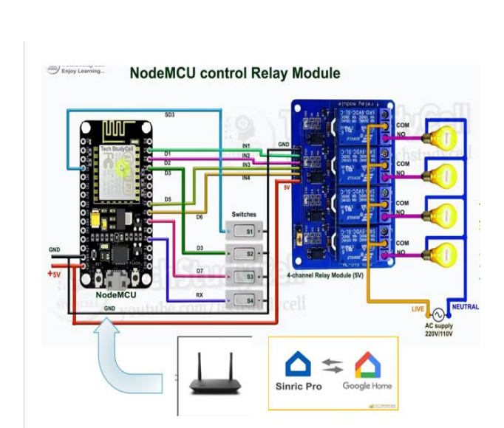

**Result:**

The developed system allows users to remotely control appliances, schedule their operation, and access previous schedules. It utilizes components such as NodeMCU, Sinric Pro, Google Home, Amazon Alexa, and relay modules. The setup involves creating a Sinric Pro account, adding devices, integrating libraries in Arduino IDE, and connecting programs like NTPClient and Sinricpro. Additionally, a simple circuit is used for the 4-channel relay module, manual switches are included for manual control, and a repurposed mobile phone charger serves as a power supply for the NodeMCU. The system also features a backup manual switch and remote operation through Google Home using virtual switches and Google Assistant.

**Conclusion:**

The IoT-based home automation system using ESP8266 and Google Home provides an efficient and user-friendly solution for remote appliance control. Its affordability and ease of use make it accessible to a wide range of users, particularly benefiting those with mobility limitations. This system demonstrates the potential of IoT technology in improving the quality of life and convenience in home environments

**Introduction**

The paper presents the implementation of IoT-based home automation using ESP8266 and Google Home. The aim is to create a voice/text-controlled home application for remote appliance control. This system is designed to enhance convenience, especially for individuals with disabilities or the elderly, using affordable and efficient technology.

**Result**

The developed system allows users to remotely control appliances, schedule their operation, and access previous schedules. It utilizes components such as NodeMCU, Sinric Pro, Google Home, Amazon Alexa, and relay modules. The setup involves creating a Sinric Pro account, adding devices, integrating libraries in Arduino IDE, and connecting programs like NTPClient and Sinricpro. Additionally, a simple circuit is used for the 4-channel relay module, manual switches are included for manual control, and a repurposed mobile phone charger serves as a power supply for the NodeMCU. The system also features a backup manual switch and remote operation through Google Home using virtual switches and Google Assistant.

**Conclusion**

The IoT-based home automation system using ESP8266 and Google Home provides an efficient and user-friendly solution for remote appliance control. Its affordability and ease of use make it accessible to a wide range of users, particularly benefiting those with mobility limitations. This system demonstrates the potential of IoT technology in improving the quality of life and convenience in home environments.Iot Based Home Automation

using ESP8266 & Googl